A000-AM,C- Costa Rica-Nicoya-Guanacaste-Terracotta Vessel Fragment-300-800 CE

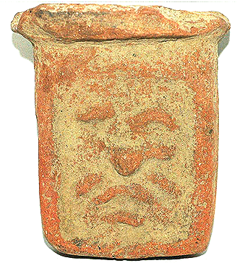

Case no.:

Accession Number:

Formal Label: Costa Rica-Nicoya-Guanacaste-Terracotta Vessel Fragment-300-800 CE

**LC Classification:** F1545.3

**Display Description:**

This Terracotta Vessel Fragment-300-800 CE has the image of a fearsome anthropomorph that may be the image of an ancestor. If so it enshrines a memory still potent in the minds of Costa Ricans today: the excesses of the Spanish Conquest:

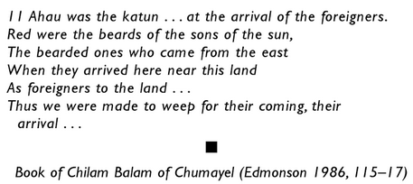

For in that arrival was the utter destruction of sacre shrines and human life as Father Barthomomé de las Casas (1484–1566), a 16th-century Spanish historian, social reformer and Dominican friar depicted it. As the first resident Bishop of Chiapas. As the first "Protector of the Indians he described the horrors of the conquest in [*A Short Account of the Destruction of the Indies*](https://en.wikipedia.org/wiki/A_Short_Account_of_the_Destruction_of_the_Indies) and *Historia de Las Indias*, depicted from his first-hand experience:

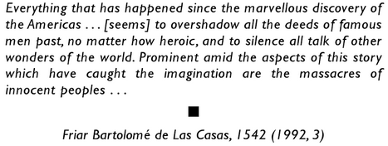

LC Classification: NK5750

Date or Time Horizon: Preclassic (300-800 CE)

Geographical Area: Costa Rica-Nicoya-Guanacaste

**Map:**

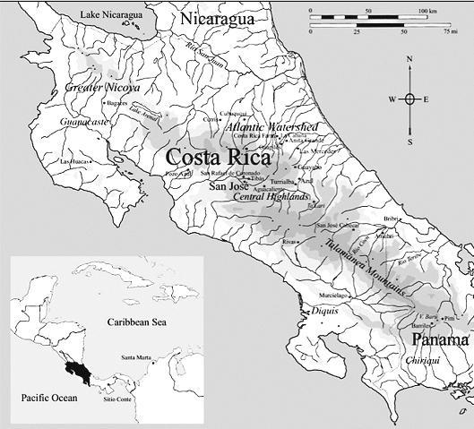

Fig. 4. Costa-Rican Archaeological regions showing Bagaces, which has been used a the geographical reference point, since the exact find location is unknown, after (Hoopes 1985)

GPS: [10°31′40″N 85°15′17″W](https://tools.wmflabs.org/geohack/geohack.php?pagename=Bagaces&params=10_31_40_N_85_15_17_W_region:CR_type:city(6569)) (Bagaces)

Medium: terracotta

Dimensions: H 9.1 cm x W 7.8 cm x D 5.9 cm

Weight:

Condition: original

Provenance: retired University of Arizona anthropology Professor Arthur Jelinek’s 1950 Collection, $49.95

**Discussion:**

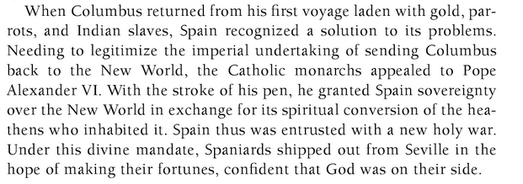

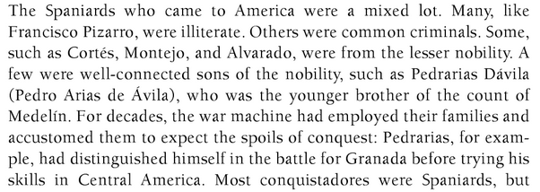

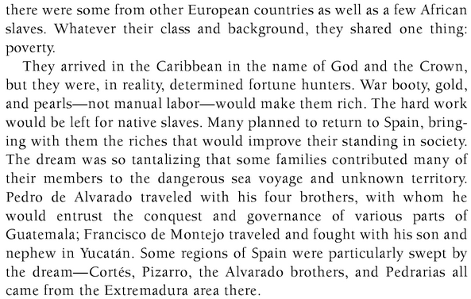

**References:**